## Initial Artifact

The projects first goal was confirming and supporting the conducted secondary research through the creation of a series of videos demonstrating cinematic elements. The video was originally to be created in Maya, which would allow for control over lighting, camera angles as well as movements of the scene. Each scene was storyboarded via a screen capture from Hogwarts Legacy. However, due to a failure in importing assets, the idea was soon scrapped, and a new software was chosen. Although, this new software/idea had to emulate as much freedom that Maya provided, the project therefore had to decide its next direction from the following:

* Creating the assets from scratch
* Creating a scene in Unity
* Creating the scene in a game
* Creating the scene in-person
* Recreating a trailer from pre-existing post-production clips

While each solution had its positives and negatives the two to stand out were unity and the game and due to [my] lack of confidence with using unity, the solution quickly became clear.

The alternative software chosen was a game called SIFU. This was chosen due to the theatre/playback mode the game allows players to use once completing a mission, thus allowing for the creation of cinematic pieces (see Fig 1).

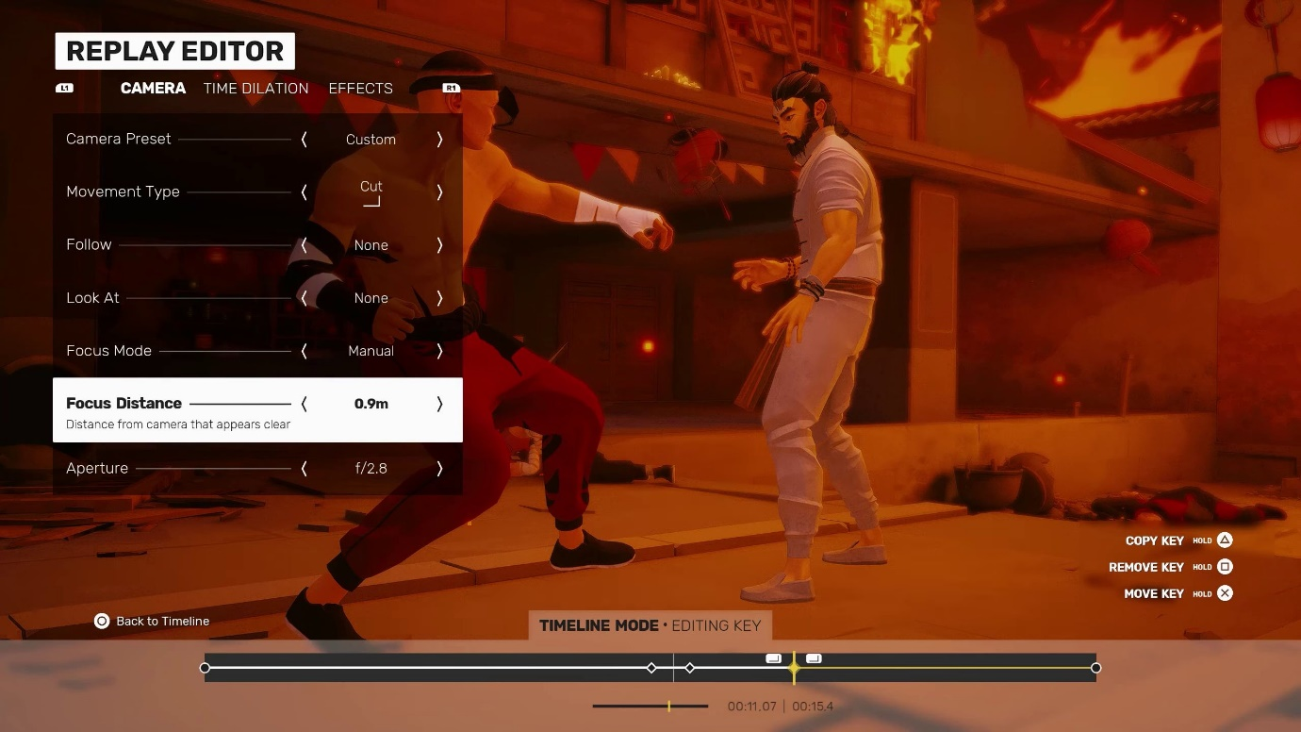

Figure - SIFU Replay Editor

However, the game has limitations such as lighting control or the most obvious problem, it has a pre-established genre. The original Maya creation was a simple storyboard of a character walking down a flight of stairs before entering a grand hall, a rather genre neutral piece. Whereas SIFU is inherently an action, martial arts fighting game, resulting in all scenes being action heavy.

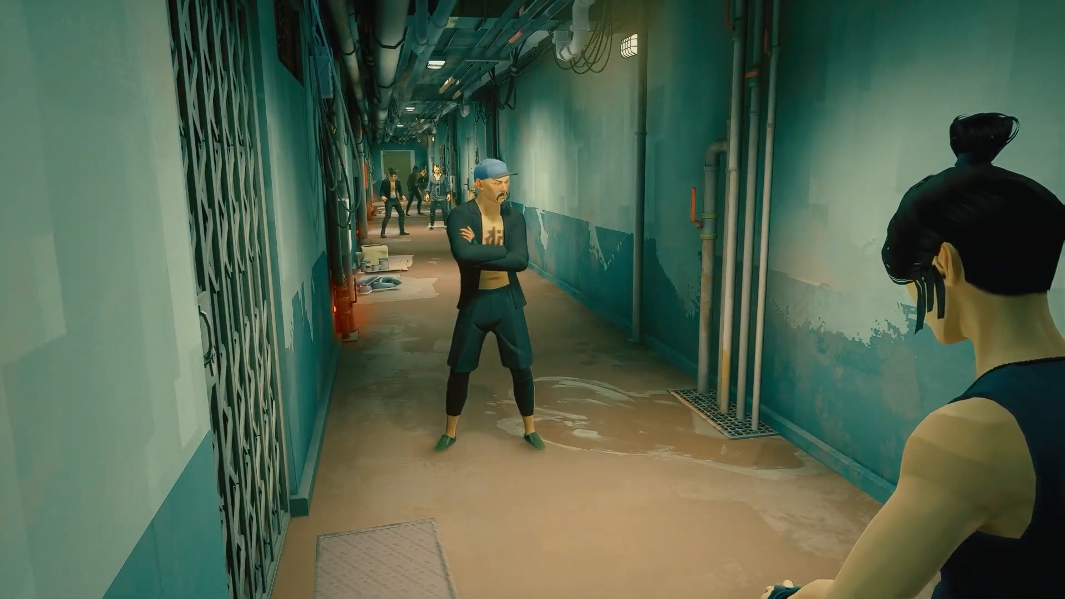

Figure - Original SIFU Scene

As seen in Figure 1, the neutral colours of the game as well as the grimy environment establish a story to the audience before any other psychological cue can. This posed a challenge in the project as displaying elements of the romantic genre as an example, would be a subversion of the action displayed. However, the project took the approach of using such challenges as a way to reiterate the research and instead confirm the significance of cinematic elements such as colour and sound.

To keep all the footage on equal standing, all eight videos shown to participants in user testing followed the same sequence of events with the same camera angles. This resulted in videos with specific elemental changes such as colour, lighting and sound added in post-production.

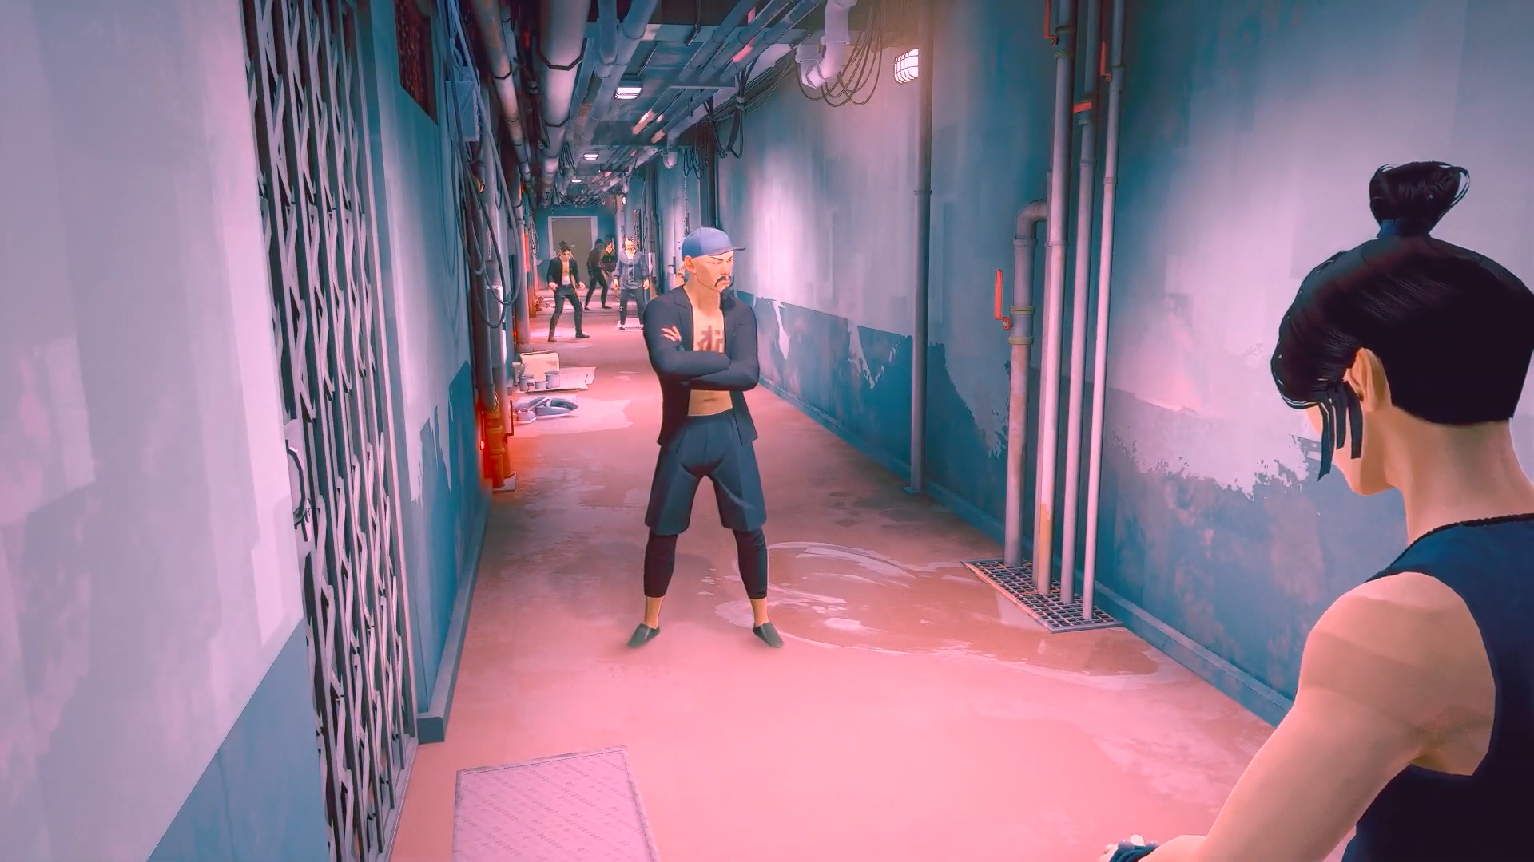

Figure - SIFU scene after post-production

The final consideration for using SIFU was the age rating being PEGI 16. As a result of this, all participants for user testing were required to be of the age of sixteen, however this was soon changed to eighteen, once videos had been rendered after post-production due to dark undertones in certain videos.

## User testing

As mentioned previously, the first round of user testing was to assess whether the research gained was of valid use. To engage with the participants, they were partaking in interviews as well as asked to speak aloud when viewing videos. Questions were geared towards enjoyment, feeling and thoughts towards cinematic elements. As a conclusive end to each video, all participants were given a chance to guess the intended genre for the videos. The implication of this question was to assess whether the cinematic elements fulfilled their intended purpose.

For many participants the action was neutral to the genres appeal due to heightened cinematic elements balancing the scene. This was evident in *Video 3* (see Fig 4), where Participant D stated, “*it didn’t feel as serious even though the action was still there. The lighting and the music made it rather jolly.”* The idea that if one element is oversaturated with detail, can counter another was an interesting thought process and appeared commonly throughout the view time of other videos.

Another factor that became clear was to not underestimate the audience. Audiences will put up with a lot of change or momentum shifts as long as it makes sense by the end of the sequence. This can be seen with *video 5*, the no genre video. *Video 5* invoked a lot of thoughts and feelings during the interviews but also while watching. *Participants* were visually and audibly confused at elements happening on the screen, but many came to a conclusion of juxtaposition which was used to demonstrate a dream state against reality. According to *Participant F,* “*I didn’t quite understand what I was watching, and I ended up getting caught trying to figure out what I was watching rather than watching.”* This was due to the jump between colour and greyscale as well as the music changing in accordance with the colour. While the confusion was very apparent as displayed in Figure 9, *Participant C* stated, “*it caught my interest, but I was still confused.”*



To showcase the results of user testing pie charts and data matrices were created to be compiled into a user testing document. Results consistently reflected the secondary research and each videos intended implication (see Fig 4).

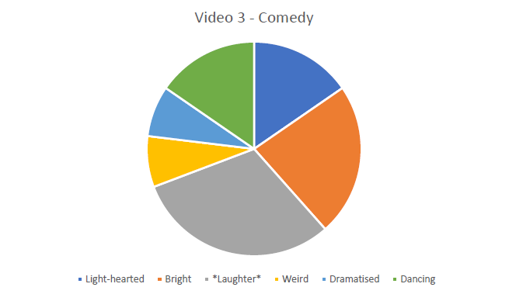

Figure - Pie Chart for Video 3 – Comedy

Finally, the project had now acquired data in the form of primary research that not only supported secondary research but allowed for the project to move towards its final artifact with data to reinforce choices made.

## Unity and Pilot Testing

During the mid stages of the project, it became apparent the project needed an artifact created from beginning to end, to showcase cinematic elements in their optimal use. This sentiment was reiterated by supervisors and peers. Due to falling short of doing so with the first artifact, the second and final artifact, which holds the intention of bringing all the elements together needed a software such as Maya or Unity. Unity was selected as the designated route and supported by lecturers due to the accessibility it gives with the use of assets and libraries pre-installed. As the project is predominantly focused on cinematic elements rather than the on-screen movement, Maya was not selected as a choice due to its main usage around 3D modelling and animation.

To utilise Unity in its full capacity, Cinemachine was recommended for the project by lecturers as an optimal route to take in creating a cinematic piece. Due to it being a package found in Unity it was easily acquired. Cinemachine is a convenient tool for creating short animations within Unity due to its ability to house multiple forms of camera angles such as a dolly camera angle to the freedom of creating a dutch angle. It made all shots possible, especially some possibly considered ‘impossible’ in a real-world setting. However, the projects progress took a dive as I had to learn the usage of Cinemachine and become reacquainted with Unity. After following a few tutorials, I soon paired Cinemachine with the Timeline package to begin recording the created scenes, using Unity assets.

These scenes were developed from an initial storyboard to demonstrate the impact of air pollution. Using the unity asset store, the scenes were to emphasise the pros and cons for the topic.

Following the creation of the initial video (see Fig 8), the project ran a pilot test with two participants. During the view time of the video, they were informed of the intention and conceptual idea of the video. Feedback predominantly anchored towards the video not fulfilling its intention and was rather off course. The video had failed and was in need of rework visually but more importantly conceptually. It was clear from the viewing; viewers fundamentally struggle with seeing the positives to air pollution as a topic but also the video did not deliver that was the message.

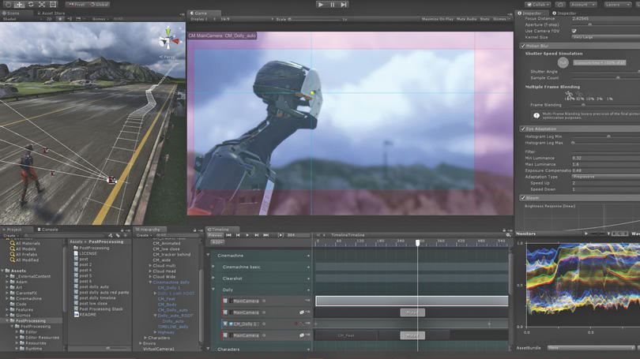

Figure - Unity Layout Using Cinemachine and Timeline

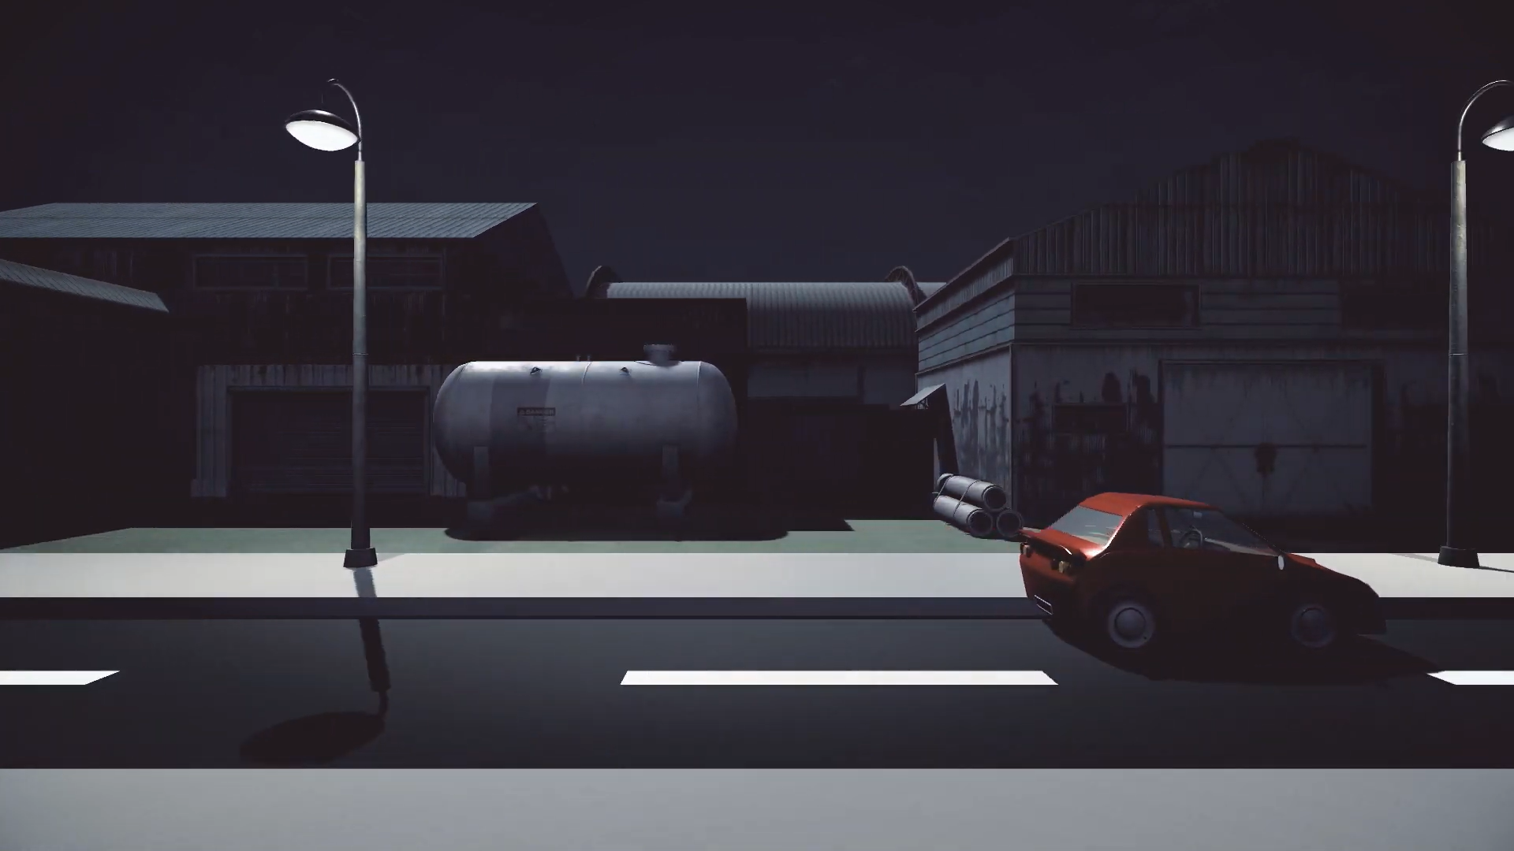

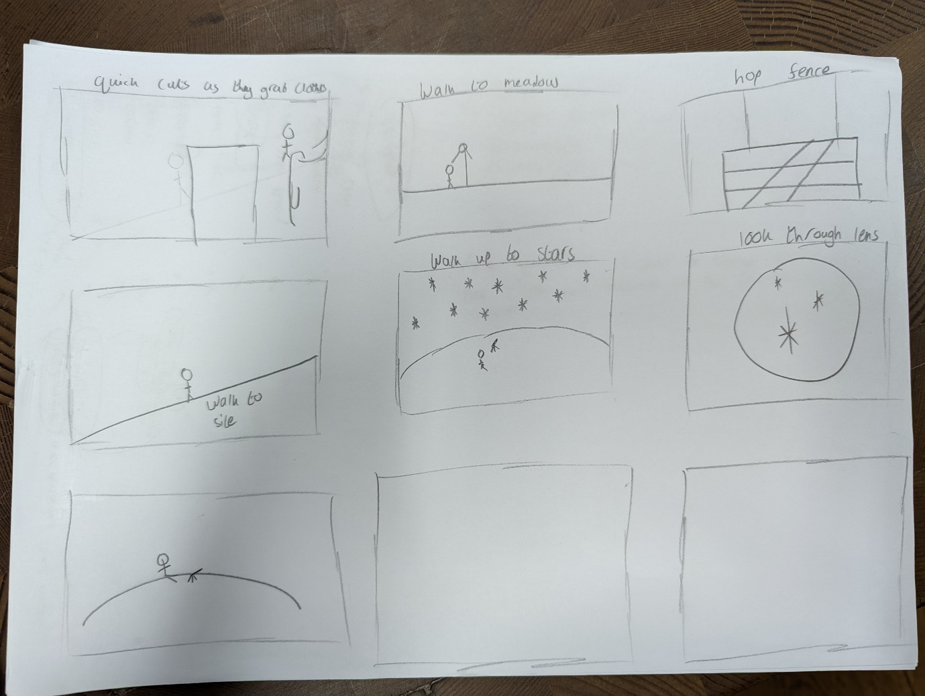

Figure - Air Pollution Storyboard

## Design brief, user personas and Storyboard

With the need of anchoring and guidance for the video, the project took a step back to face the problem. The original idea of air pollution was changed to a more empathetic issue, animal captivity within Zoos. Taking inspiration from a user experience approach, a design brief was created to keep thoughts on track as well as towards a specific agenda.

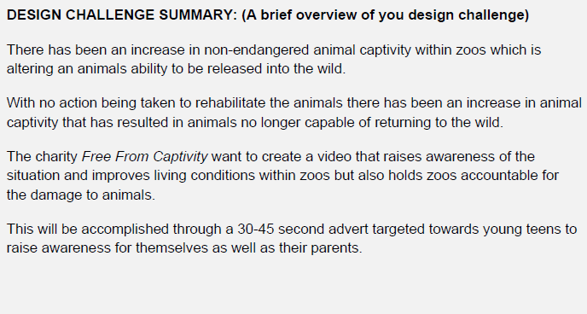

The idea of grounding the advert was taken a step further by creating a fictional charity, *Free From Captivity.* This allowed for a targeted approach towards the advert, with a fixed goal/outcome. The process from this point involved creating user personas towards the target audiences as well as the charity itself.

* Free From Captivity – a charity seeking to increase awareness of the benefits and pitfalls of zoos. Being a very modern and social media heavy company, they are seeking a video to be accessed across all platforms.
* Caroline Shaw – a parent who cares for their children, she doesn’t want them to be shown harmful content.
* Rebecca Cloud – a young teen who loves animals and the world around her who often watches tv to see glimpses of animals in her favourite shows. Typically asks her parents for objects/activities advertised on the TV.

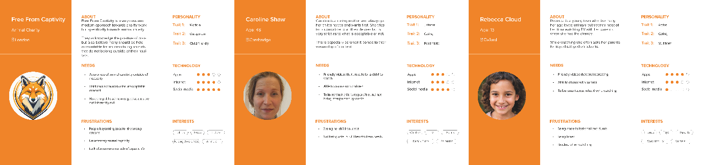

A decision was made to create one video, which will showcase both sides of the story rather than two contrasting videos. Therefore, the narrative will display that zoos are enjoyable and there is no guilt for going to one and seeing exotic animals. However, the dark undertones such as illegal animal captivity or poor living conditions should be considered. The reasoning behind one video was a result of the previous user testing. The intended advert will be reminiscent of *Video 5 – No Genre.* Although, utilising the personas and design brief, the video will contrast in a more formatted way. Taking into consideration feedback from participants, such as Participant H saying, “if you wanted to escalate it, do it gradually. If you wanted to go from greyscale to colour… leak in colour.”

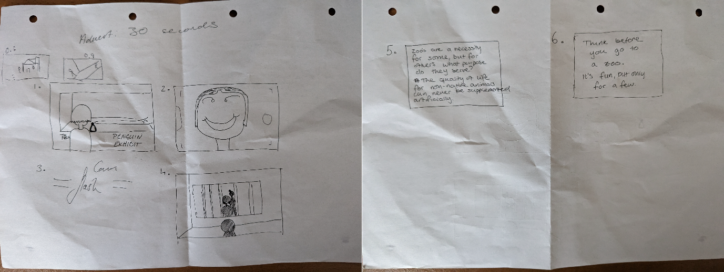

The advert is designed to air during children tv to target the youth, by influencing their thoughts on the matter they will push for change, thus hitting the true target audience - parents. Parents/adults are the true people who can bring about change to the situation, however, to get them to move they need a strong catalyst – children. For this to happen an emotional response will need to be triggered within the children inside of a 30-45 second timespan. In this timespan, a problem needs to be suggested, accompanied by a call to action for the children to seek their parent.

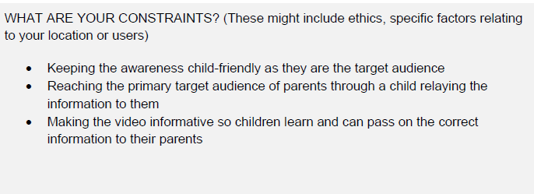

While the narrative and outcome have been considered, the project faces a few ‘constraints’. The advert needs to be child friendly as to not scare the children from never going to zoos as that is not the intention. Additionally, this would neglect the needs of a parent’s user persona, due to wanting to keep their child safe. The video should instead engage a child’s love for animals as well as play on their need to make change, resulting in parents to fulfil their child’s desire.

## Final video creation & user testing

The narrative plot for this story was kept simple but engaging. The video appears to start as a Zoo advertisement, pushing for the audience to visit their Zoo, however a twist in the action at the end of the story displays the unfortunate circumstances of the penguin. The tonal shift is accompanied by different lighting, created within Unity.

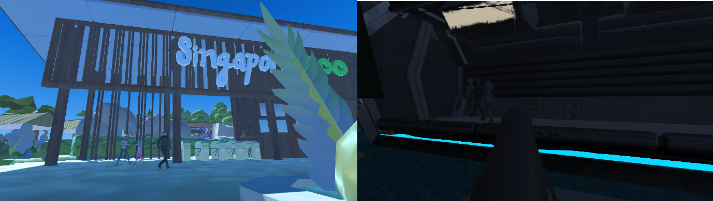

The final video was created using a mixture of Adobe Premier Pro and After Effects, similarly to the videos created for SIFU. Following the events of the storyboard and the emotional points that needed to be hit, the editing was used in a way to exaggerate shots. This was concluded after the previous pilot testing for the air pollution videos, where the main point of feedback was a lack of narrative and emotional response. To not miss such pivotal aspects for the next video, elements were pushed to their limits. This was a direct result of the user testing stated earlier, by oversaturating one element it can force a user attention and steer it towards the intended message.

One such instance can be seen when accentuating the tonal difference in Fig … While already clear, emphasising the lighting through further colour grading brings a more impactful message to the audience, this was reinforced when pilot testing was run for this scene and the green lighting in the shot of the penguin was requested to be decreased due to the colour being rather ominous.

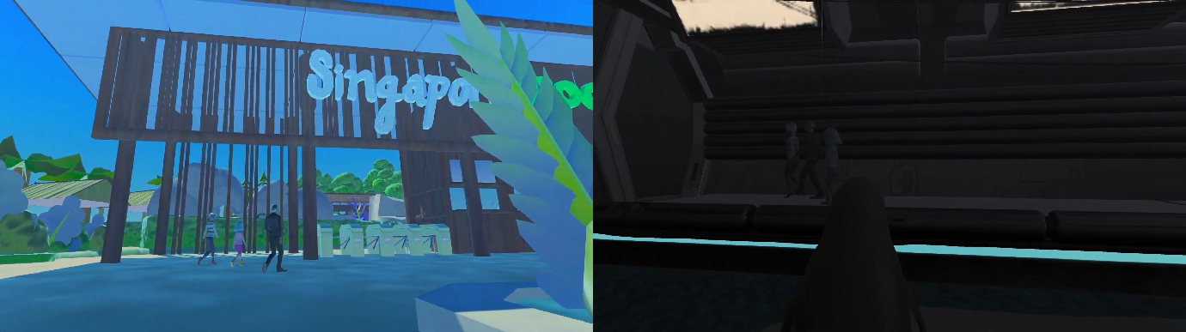

Wanting to make the scene more empathetic and relatable to the audience dialogue was added to the human characters to verbally showcase their excitement and amazement of their surroundings. This juxtaposes the penguins narrative of silence, the only sound to be heard is the non-diegetic sound of music.

The results from user testing demonstrate that the implementation and exaggeration of elements added post-production were of powerful effect. One participant stated, “The different tones of blue help to add both joy (through the light blue) to the scene as well as the sadness through the dark blue/black of the penguin scene.” This opinion was rather unanimous and supports the decision to alter the colouring and lighting of the scene. Rather conclusively, many of the users thought the video achieved its required goal and in a very accessible manner. A common thought from users was worded elegantly by this user in particular, “the dark lighting in the final scene was very sad. It was also a sharp flip to invert the perspective from the people to the penguin. This completely changed the tone of the film.”

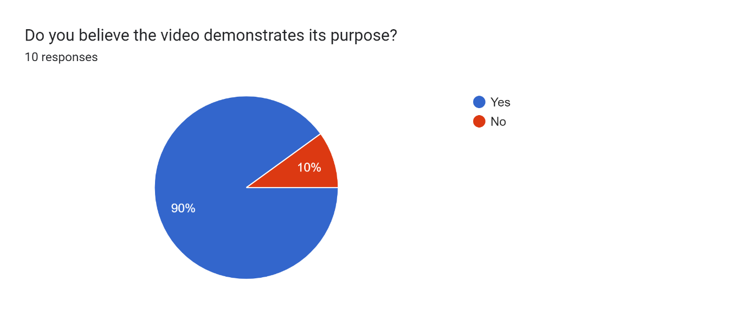

Overall, the results of the video seemed rather positive, and it appears to have hit the desired outcome. However, the narrative was misunderstood by many because of the final dark twist at the end. While the contrast of the video did inflict thought and understanding of animal cruelty, it had failed in informing the audience that there should be no guilt in visiting zoos to see their favourite animals. Many took the video as awareness to boycott zoos rather than stand-up for the zoos and the animals. Therefore, a required change for the video would be the beginning portion and creating an atmosphere of welcoming, this can be reiterated in the final portion of the video which contains text informing users of the current situation.

